**Data Service for Hadoop cluster**

## Infrastructure

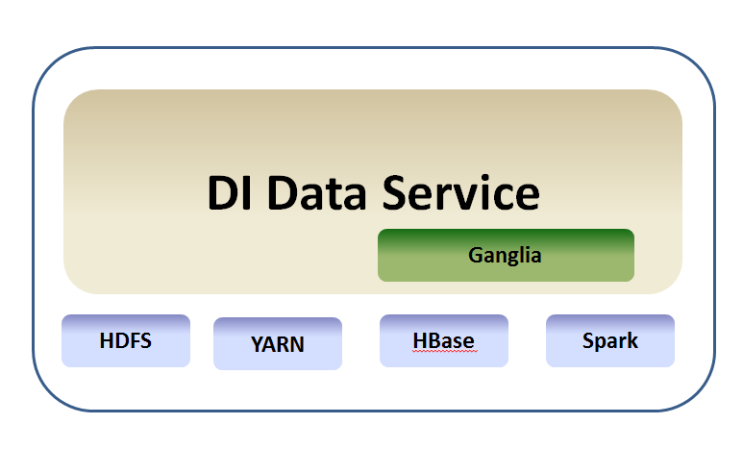

DI data Service leverage Ganglia to get almost of metric from Hdfs, Yarn, HBase, Spark and so on. The Service will also get the metric by JMX service or any other API from the cluster.

## How to build and deploy

Create table by the script of /di-data-service/src/main/resources/script/di.sql

Configured /di-data-service/src/main/resources/conf/di.properties for some invironment

Depend on Maven, and run command under the folder:

mvn clean install

Put the war package to web container like ‘tomcat or jetty’

## API list

User File Count: <http://192.168.81.177:8089/di-data-service/hdfs/get/userfileinfo>

Job Success Rate：<http://192.168.81.177:8089/di-data-service/yarn/get/jobsuccessrate>

Job Success Count：<http://192.168.81.177:8089/di-data-service/yarn/get/jobsuccesscountbydate>

Job count by user on yesterday：<http://localhost:8080/di-data-service/yarn/get/jobnewestuserjobcount>

Job detail count：[http:// localhost:8080/di-data-service/yarn/get/jobcountdetail](http://192.168.81.177:8089/di-data-service/yarn/get/jobcountdetail)

Job detail count by user：[http:// localhost:8080/di-data-service/yarn/get/jobcountdetailbyuser](http://192.168.81.177:8089/di-data-service/yarn/get/jobcountdetailbyuser)

Ganglia cluster info: [http:// localhost:8080/di-data-service/ganglia/clusterinfo](http://192.168.81.177:8089/di-data-service/ganglia/clusterinfo)

Get Critical Metric By Cluster Name：[http:// localhost:8080/di-data-service/metric/getmetriclist?clustername=hbase-cluster-test-source](http://192.168.81.177:8089/di-data-service/metric/getmetriclist?clustername=hbase-cluster-test-source)

Get all the Metric by Cluster Name：[http:// localhost:8080/di-data-service/metric/getallmetriclist?clustername=hbase-cluster-test-source](http://192.168.81.177:8089/di-data-service/metric/getallmetriclist?clustername=hbase-cluster-test-source)

Job Count by User and date：[http:// localhost:8080/di-data-service/yarn/get/jobuserjobcountbydate?date=5](http://192.168.81.177:8089/di-data-service/yarn/get/jobuserjobcountbydate?date=5)

Job Success Rate by date: [http:// localhost:8080/di-data-service/yarn//get/jobsuccessrate?date=5](http://192.168.81.177:8089/di-data-service/yarn/get/jobsuccessrate?date=5)

Job Success Count by date: [http:// localhost:8080/di-data-service/yarn/get/jobsuccesscountbydate?date=5](http://192.168.81.177:8089/di-data-service/yarn/get/jobsuccesscountbydate?date=5)

Job Count by page: [http:// localhost:8080/di-data-service/yarn/get/jobcountdetailbypage?page=2&show=10](http://192.168.81.177:8089/di-data-service/yarn/get/jobcountdetailbypage?page=2&show=10)

Job detail count by user and page: [http:// localhost:8080/di-data-service/yarn/get/jobcountdetailbyuserandpage?page=4&show=10](http://192.168.81.177:8089/di-data-service/yarn/get/jobcountdetailbyuserandpage?page=4&show=10)

Job count by date or username: [http:// localhost:8080/di-data-service/yarn/get/jobcountdetailbyuserordate?search=you](http://192.168.81.177:8089/di-data-service/yarn/get/jobcountdetailbyuserordate?search=you)

Hdfs usage situation: [http:// localhost:8080/di-data-service/hdfs/get/hdfsusageinfo](http://192.168.81.177:8089/di-data-service/hdfs/get/hdfsusageinfo)